**ECOMMERCE SPORTY SHOES PROJECT REQUIREMENT**

**INTRODUCTION:**

E-commerce is fast gaining ground as an accepted and used business paradigm. More and more

business houses are implementing web sites providing functionality for performing commercial

transactions over the web. It is reasonable to say that the process of shopping on the web is

becoming commonplace.

OVERALL DESCRIPTION:

**Description:**

* Any member can register and view available products.
* Only registered member can purchase multiple products regardless of quantity.
* Contact Us page is available to contact Admin for queries.

There are three roles available: Visitor, User and Admin.

• Visitor can view available products.

• User can view and purchase products.

• An Admin has some extra privilege including all privilege of visitor and user.

* Admin can add products, edit product information and add/remove

product.

* Admin can add user, edit user information and can remove user.
* Admin can ship order to user based on order placed by sending

confirmation mail

**Using the code:**

* Attach the database.
* Run and build maven

<modelVersion>4.0.0</modelVersion><groupId>SportyShoes</groupId><artifactId>SportyShoes</artifactId><packaging>war</packaging><version>0.0.1-SNAPSHOT</version><name>Section7LEP Maven Webapp</name><url>http://maven.apache.org</url

* Session factory with hibernate
* <wb-resource source-path="/target/m2e-wtp/web-resources" deploy-path="/"/><wb-resource source-path="/src/main/webapp" deploy-path="/" tag="defaultRootSource"/><wb-resource source-path="/src/main/java" deploy-path="/WEB-INF/classes"/><wb-resource source-path="/src/main/resources" deploy-path="/WEB-INF/classes"/><wb-resource source-path="/src/test/java" deploy-path="/WEB-INF/classes"/><property value="SportyShoes" name="context-root"/>

**Master Page details:**

* Online Shopping Master Page (Similar Master Page for Visitor, User and Admin)

**Web Pages details:**

* Home Page
* About Us Page
* Product Page
* Contact Us Page
* Privacy policy
* FAQs
* Admin Page
* Login Page
* Register Page

**Project Detail- Online shopping**

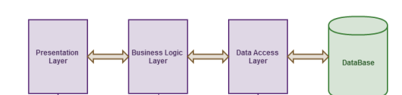

**Use Case diagram**

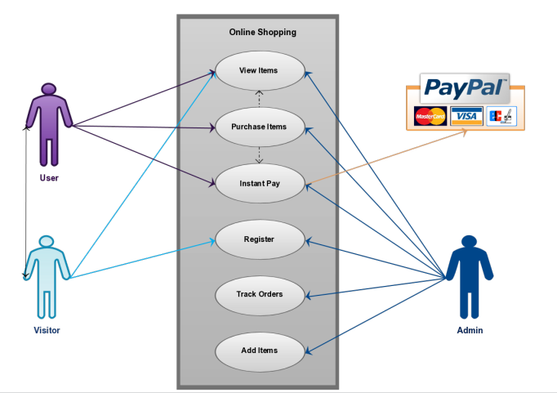

**Data Management**

This database consists of

**Users**: User and Admin information is added to database with Unique ID based

on their roles.

**Shopping:** Complete products information is stored in this table.

**Orders**: Customer ordered products, status and delivery information is stored in

this table.

**Data Object**s

**User**: ID, User Name, Password, Email, Role

**Shopping**: ID, Product, Product ID, Cost, Category, Image, Description

**Orders**: ID, Client, Product, Quantity, Price, Date, Order Shipped

**Message:** Customer Email, Message

**Database Table Diagram**

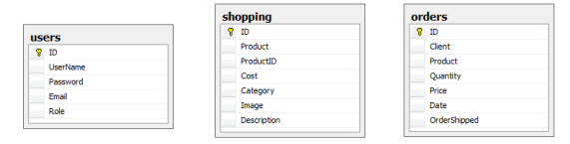

**Relationships**

